Due to the emergence of covid pandemic and closing down of all educational institutions as per Government guidelines, it was not possible to organize any event with physical presence. Therefore as an alternative way, ten webinars were organized by different academic departments as advised by IQAC. The details of the webinars are given below.

**National Webinar on Cloud Computing and its impact on Library Services**

Date: 15- 17 May, 2020 Time: 3.00 to 5.00 pm

|  |  |
| --- | --- |
| Organiser | Resource person(s) |
| Naharkatiya College | Dr. Sanjay Kumar Singh, Professor and Head, Department of Library and Information Science, Gauhati University, Guwahati, Assam.  Dr. S. Ravikumar, Asst. Professor, Department of Library and Information Science, North Eastern Hill University, Shillong: Assam.  Dhanwantari Prakash Tripathi, Assistant Librarian, National Institute of Technology, Rourkela, Sundargarh, Odisha, India. |

Coordinator: Shri Suraj Gogoi

Number of participants: 502

**National Webinar on Academic and Research Integrity**

Date: 27 & 28 May, 2020 Time: 2.30 to 5.00 pm

|  |  |
| --- | --- |
| Organiser | Resource person(s) |
| Naharkatiya College | Prof. (Dr.) Ramesh C Gaur, Dean & Head Kala Nidhi at Indira Gandhi National Centre for the Arts, Ministry of Culture, Govt. of India.  Dr. Utpal Das, Deputy Librarian, Dibrugrah University, Dibrugrah : Assam.  Dr. S. Ravikumar, Assistant Professor, Department of Library & Information Science, North Eastern Hill University, Shillong: Meghalaya.  Dr. Tilak Hazarika, Assistant Professor, Department of Library & Information Science, Guahati University, Guwahati, Assam. |

Coordinator: Shri Suraj Gogoi

Number of participants: 674

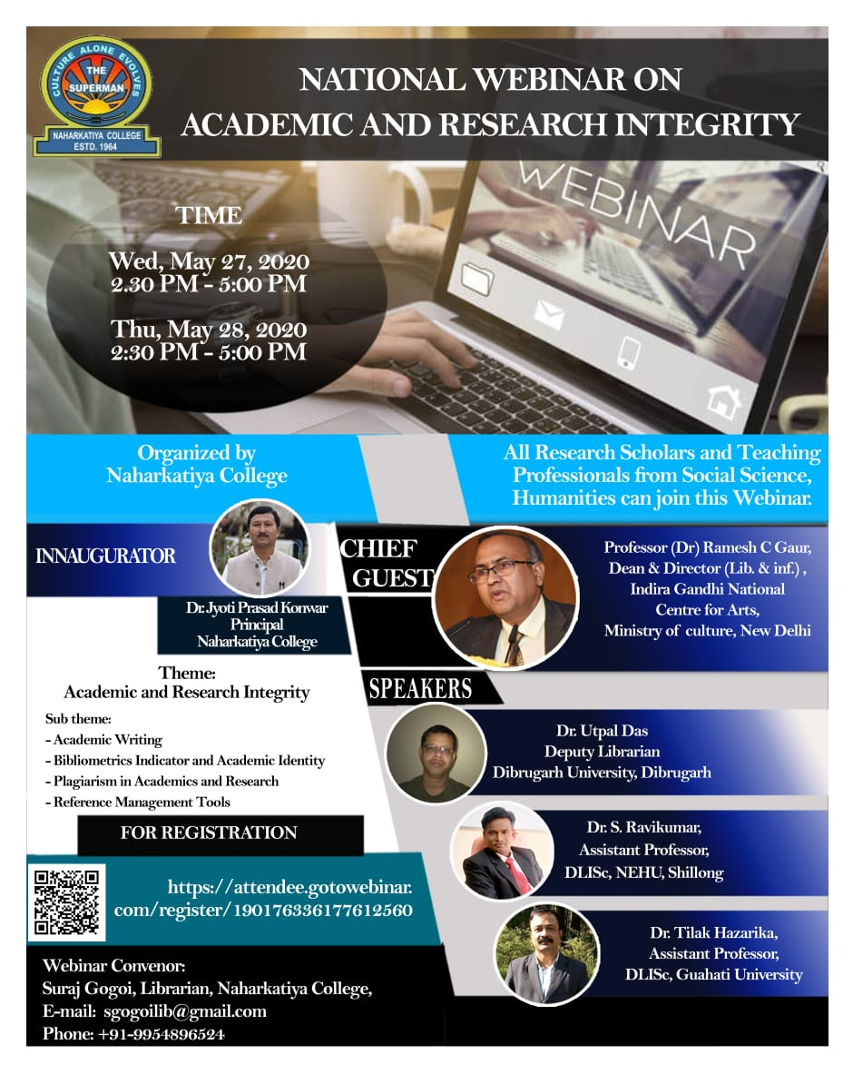

Virtual Workshop on Design and Development of Digital Repository using DSpace

Date: 30 & 31 May, 2020 Time: 2.15- 5.00 pm

|  |  |
| --- | --- |
| Organiser | Resource person(s) |
| Central Library and IQAC, Naharkatiya College | Prof. Parthasarathi Mukhopadhyay, Professor (HoD), Department of Library & Information Science , Kalyani University, Kolkata: West Bengal.  Sher Afzal Khan, President Koha Pakistan, Lead Consultant, HEC approved trainer for Libraries, Pioneer Country Ambassador of DSpace MIT USA.  Dr. Dipen Deka, Assistant Professor, Department of Library & Information Science, Guahati University, Guwahati, Assam.  Dr. Gautam Kumar Sarma, Assistant Librarian, Krishna Kanta Handiqui State Open University, Guwahati, Assam |

Coordinator: Shri Suraj Gogoi

Number of participants: 424

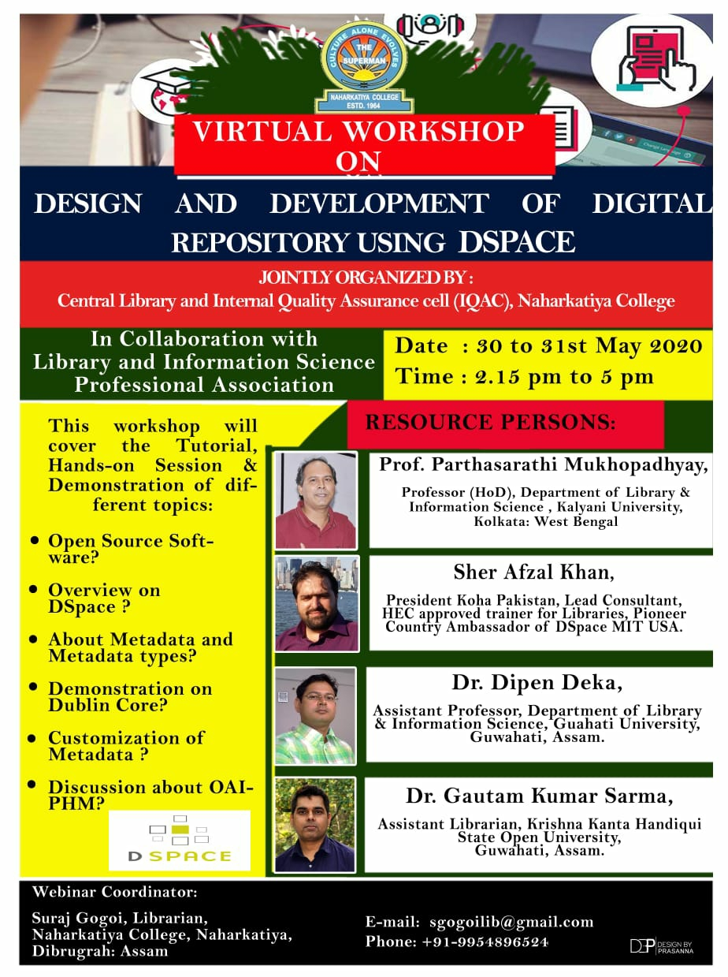

Virtual Orientation Programme on Electronic Resources and E-learning Platform

Date: 08/06/2020 Time: 11 am – 12.30 pm

|  |  |
| --- | --- |
| Organiser | Resource person(s) |
| Central Library,  Naharkatiya College | Dr. Pranab Kumar Barooah, Professor, DLISc, University of Science Technology and Management, Meghalaya  Sri Hirak Jyoti Hazarika, Research Scholar, DLISc, North Eastern Hill University, Shillong |

Coordinator: Shri Suraj Gogoi

Number of participants: 397

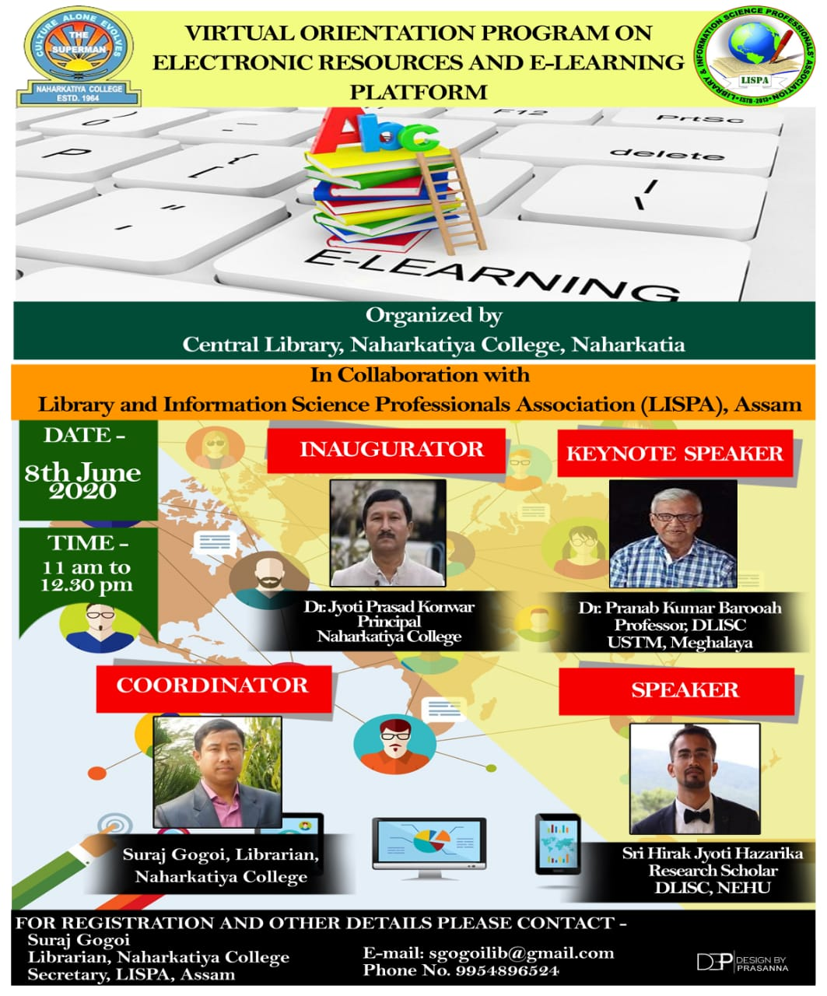

Career Opportunities in English Language and Literature

Date: 27/06/2020 Time: 11am-12 pm

|  |  |
| --- | --- |
| Organiser | Resource person(s) |
| Dept. of English,  Naharkatiya College | Nabanita Hazarika, Assistant Professor, Dept. of Language Studies (English), Assam Don Bosco University, Guwahati |

Coordinator: Mrs. Karabi Hazarika

Number of participants: 150

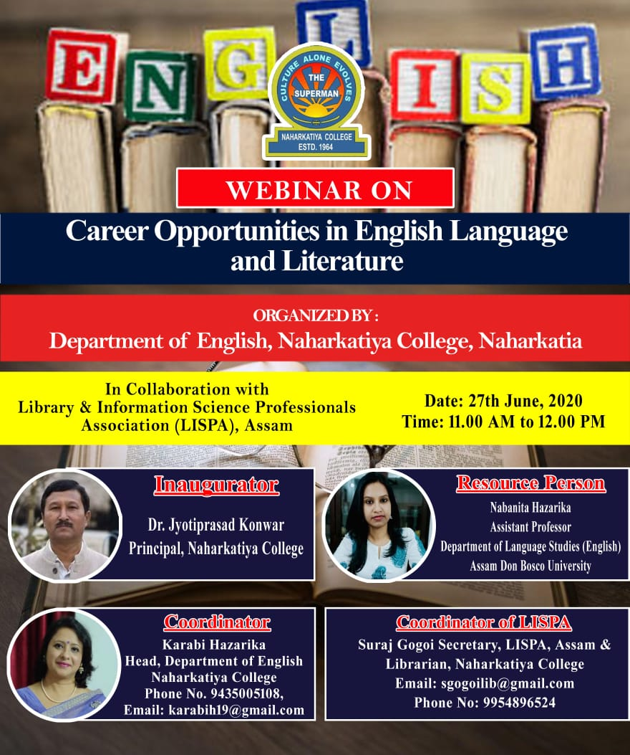

Behavioural Finance: A Curtain Raiser

Date: 30/06/2020 Time: 11 am-12 pm

|  |  |
| --- | --- |
| Organiser | Resource person(s) |
| Dept. of Commerce,  Naharkatiya College | Prof. Amalesh Bhowal, Dept. of Commerce, Assam University (Diphu Campus), Diphu |

Coordinator: Dr. Amlan Jyoti Sharma

Number of participants: 116

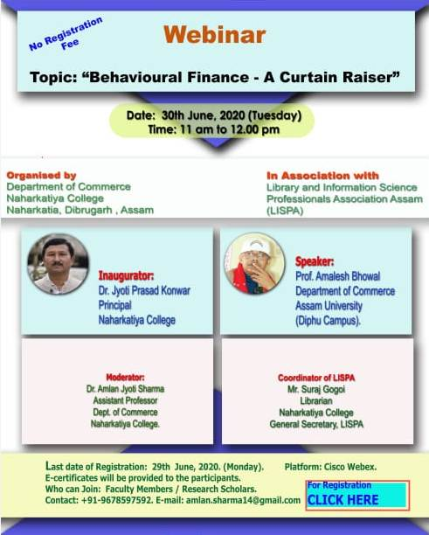

**Importance of Mental Health of the Students for Leading a Well-balanced Life**

Date: 02/07/2020 Time: 11 am

|  |  |
| --- | --- |
| Organiser | Resource person(s) |
| Dept. of Education,  Naharkatiya College | Dr. Indrani Kalita, Asst. Professor, Dept. of Education, Krishna Kanta Handique State Open University, Guwahati |

Coordinator: Dr. Anita Mahanta

Number of participants: 397

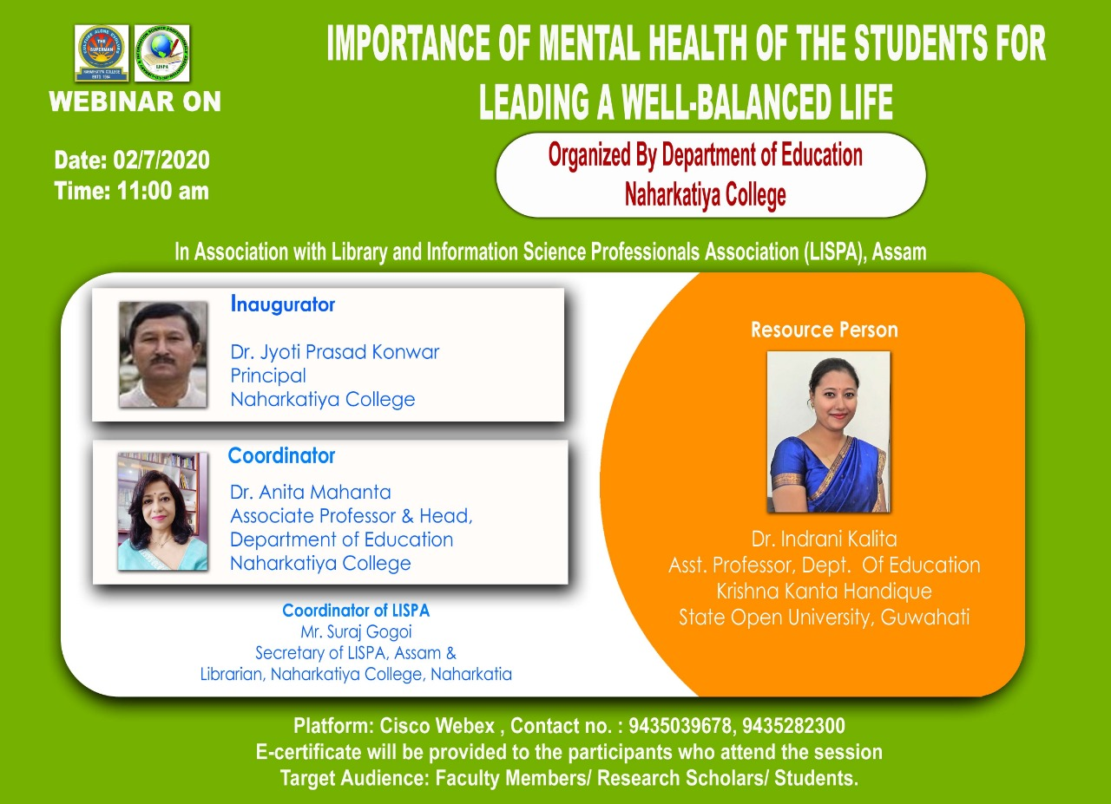

**Indo-Chinese Relations: Co-operation and Conflict in Historical Perspective**

02/07/2020 Time:3 pm

|  |  |
| --- | --- |
| Organiser | Resource person(s) |
| Dept. of History & Dept. of Political Science,  Naharkatiya College | Prof. Biswajeet Baruah, Dept. of History & Dean, School of Social Sciences, Dibrugarh University, Dibrugarh |

Coordinator: Dr. Ananta Baruah & Nilam Hazarika

Number of participants: 112

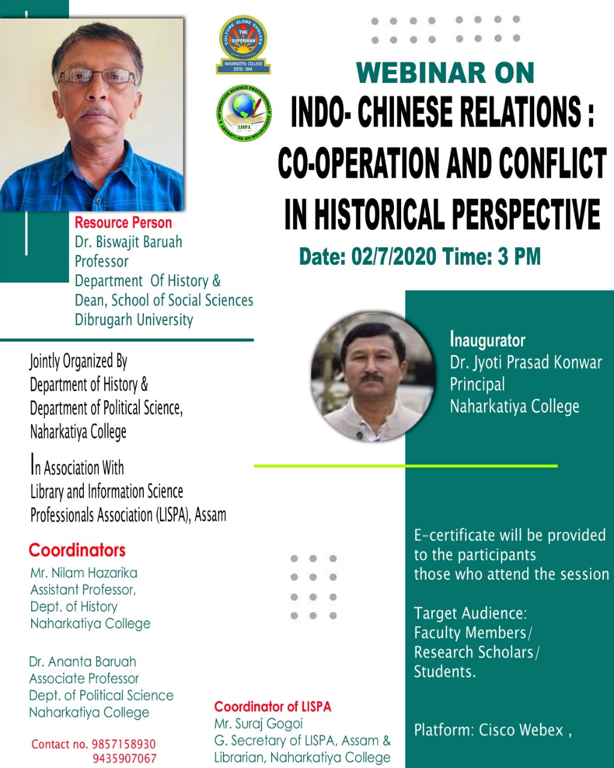

**বৈদ্যুতিন মাধ্যমত পৰিৱেশিত বাতৰি আৰু বিজ্ঞাপনৰ ভাষাশৈলী**

06/07/2020 Time: 11 am-12.30 pm

|  |  |
| --- | --- |
| Organiser | Resource person(s) |
| Dept. of Assamese,  Naharkatiya College | Dr. Satyakam Borthakur, Dept. of Assamese & Chairperson, CSJMC, Dibrugarh University, Dibrugarh  Dibyajyoti Sarmah, Asst. Prof., Centre for Studies in Journalism and Mass Communication, Dibrugarh University, Dibrugarh |

Coordinator: Dr. Smrity Rekha Gogoi Gayan

Number of participants: 268

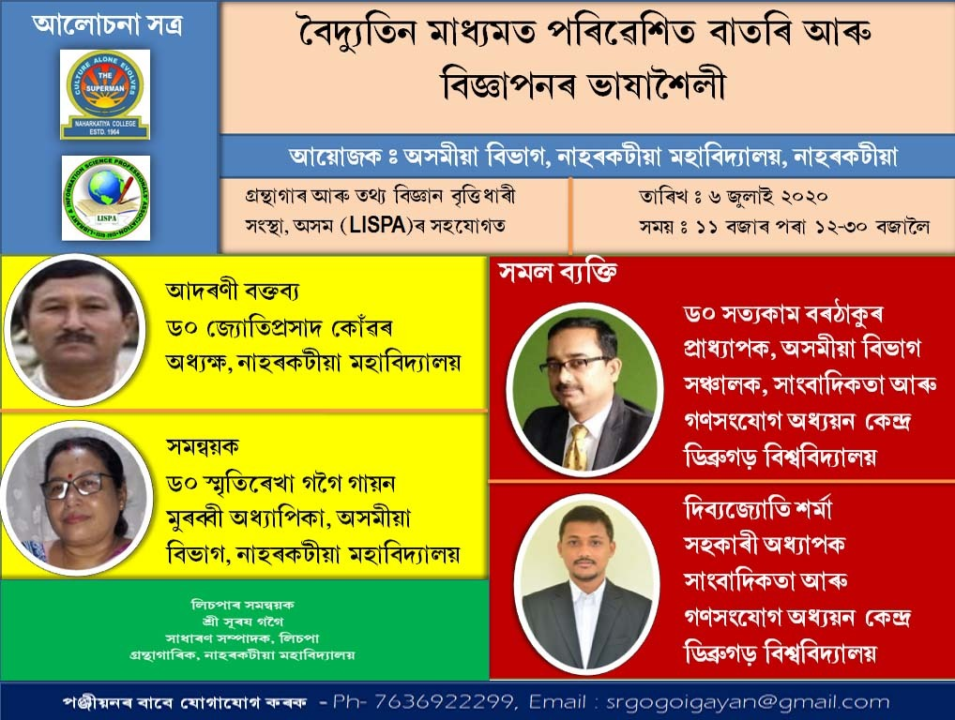

**Indian Economy and Covid-19 Pandemic**

17/07/2020 Time:11 am-12 pm

|  |  |
| --- | --- |
| Organiser | Resource person(s) |
| Dept. of Economics,  Naharkatiya College | Dr. Amarjyoti Mahanta, Head & Associate Prof., Dept. of Economics, Dibrugarh University, Dibrugarh |

Coordinator: Mr. Diganta Tamuli

Number of participants: 160

